**What is Log-odds?**

What is Log-odds?

The Log-odds are the way to express the probability of a sample data belonging to positive class.

For example- Calculating the probability of student passing the exam.

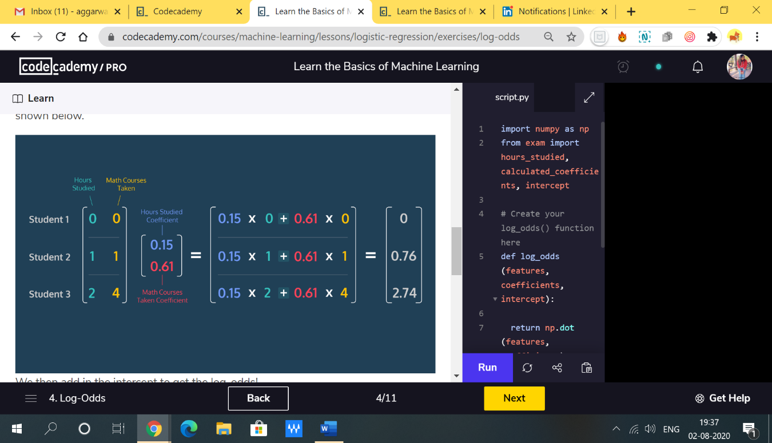In Logistic Regression, we perform the multiplication of feature coefficients and feature values and add the intercept, we get z what is called the log-odds.

*z*=*b*0​+*b*1​*x*1​+⋯+*bn*​*xn*​

where b0 is the intercept

b1, b2, b*3*…, bn are the coefficients of the features *x1, x2, …..., xn*​​ .

We can perform using numpy library with dot product function.

log_odds = np.dot(features, coefficients) + intercept

Therefore, Logistic Regression work with the sigmoid function to link the log-odds of a data point to the range [0,1] and provide the probability of a classification class.